OIL Investment Opportunıtıes IN NIGERIA
OPEN SOURCES INTELLIGENCE REPORT
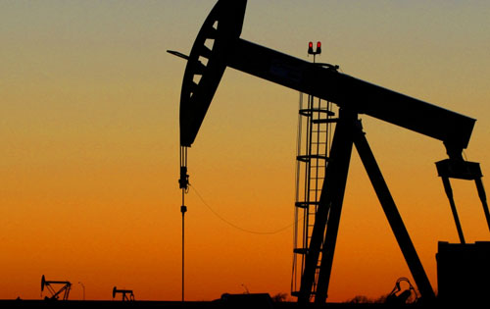
Prepared by: Tolga Golbasi Yakubu Yunusa Abdul Ahadd

Advanced Information Security Report
Yasar University, Izmir, Turkey

Requirements
Our wealthy investor requests from us to answer if investing in Nigerian oil fields is worthy business.
Milestones
- December 10th Interim report
- December 17th Draft report
- December 24th Final report
Requirements Analysis
Our goal is to find out investment opportunities in Nigerian oil fields.
We can split this goal into several parts:
- What is oil?
  - What are uses of oil?
  - How oil production is done?
- What is future of oil?
  - What is supply figures in oil?
  - What is demand figures in oil?
  - What is historical performance of oil prices?
  - What is forecast for oil prices?
- What is the status of Nigerian oil fields?
  - What is the history of Nigerian oil fields?
  - Which companies currently invested?
  - What are their returns?
  - How we send oil to customers?
- Why should we choose Nigeria for our investment?
  - What are the incentives for investing in Nigeria?
  - What are risks of investing in Nigeria?
  - What are regulations over oil production?
  - What are costs of investing in Nigerian oil fields?
Following approaches to achieving the objectives have been identified
Problem Solving Techniques
In order to answer these questions we will use special techniques. These will include:
- Paraphrase:Restate the problem using different words without losing the original meaning. Trying to say the same thing with different words puts a slightly different spin on the meaning, which triggers new perspectives and informative insights.
- 180 Degree: Turn the problem on its head. Taking the opposite view not only challenges the problem's underlying premises but also directly identifies what is causing the problem.
- Broaden the focus: Restate the problem in a larger context, Look at the implications of the initial problem beyond the confines of your own organization.
- Redirect the focus: Boldly, consciously change the focus. Using creative thinking, look at the problem from an entirely different perspective.
- Ask “why”: Ask “why” of the initial problem statement. Then formulate a new problem statement based on the answer. Then ask “why” again, and again restate the problem based on the answer. Repeat this process a number of times until the essence of the “real” problem emerges. Restating a problem several different ways is a divergent analytical technique that opens the mind to alternatives.
Source: Morgan D.Jones. The Thinker's Toolkit. New York:Three Rivers Press,1995
Open Source Information Sources
An important subset of open source information is called Grey Literature. The Interagency Grey Literature Working Group(IGLWG) is defined as follows:
“Grey literature, regardless of media, can include, but is not limited to, research reports, technical reports, economic reports, trip reports, working papers, discussion papers, unofficial government documents, proceedings, preprints, research reports, studies,dissertations and theses; trade literature, market surveys, and newsletters. This material cuts across scientific, political, socio-economic, and military disciplines.”
The ability to search internet or in essence, millions of pages of text within seconds, has proven to be the reason for the rise in popularity of open source information.
Open sources will be used are:
- Governmental Websites
  - Official Website of the Nigerian Investment Promotion Commission (NIPC) http://www.nipc.gov.ng/
  - Official Website of the Nigerian Export Promotion Council http://www.nepc.gov.ng/
  - Official Website of the Federal Ministry of Finance http://www.fmf.gov.ng/
  - Official Website of the Nigeria Petroleum Technology Development Fund http://www.ptdf.gov.ng/
- Search Engines
  - www.google.com
  - www.bing.com
- Academic Databases
  - scholar.google.com
  - African Journals Online (AJOL) http://www.ajol.info/
  - Web of Knowledge http://www.webofknowledge.com/
  - The Information Bridge: U.S. Department of Energy Scientific and Technical Information http://www.osti.gov/bridge/index.jsp
  - OpenGrey Grey Literature database http://www.opengrey.eu/
- News Websites
  - Reuters www.reuters.com
  - BBC News http://www.bbc.co.uk/news/world/
  - Vanguard Nigerian News website http://www.vanguardngr.com/
  - NigeriaWorld Nigerian News Website http://www.nigeriaworld.com/
  - The Guardian Nigerian News Website http://www.ngrguardiannews.com/

Data Collection
For the purpose of making use of the techniques involved in finding data/information in writing open source intelligence report for authentication, we sources the information through Google search using different search engine by direct link to governmental sites and organizational sites to ensure all the resources were from true sources and will at the same time make the customers have confidence in investing their money in Nigerian oil production. For example the information was derived some in form of text to be store while others in form of images. Therefore, the storing aspect of the data were done with credibility measure and specific storing format to make sure the data were written based on intelligence reasoning.
Credibility Measure: The degree to which people believe and trust what other people and organizations tell them about a particular product or service, and this were confirmed by following any possible hyperlink during data gathering.
Source no: | <Unique number>
Source name: | <Source name>
Credibility: | <Credibility assesment>
Date: | <Date>
Source adress: | <Link to source>
Contents: | <Short descripton of source>

The illustrated sample of how the data was gathered in order to suite the investors to feel free of the information source and the detail will be discuss in the next chapters.
Source Evaluation
In order to evaluate our sources effectively we will be using a evaluation checklist as follows:
1-Authority
- Is it clear which organization is behind the contents of the page?
- Is there a link to a page describing goals of the organization?
- Is there a way of verifying the legitimacy of this organization?
2-Accuracy
- Are the sources for any factual information clearly listed so they can be verified in another source?
- Is the information free of grammatical, spelling, and typographical errors?
3-Objectivity
- Are the organization's biases clearly stated?
- If there is any advertising on the page, is it clearly differentiated from the informational content?
4-Currency
- Are there dates on the page to indicate:
  - When the page was written?
  - When the page was first placed on the web?
  - When the page was last revised?
- Are there any other indications that the material is kept current?
5-Coverage
- Is there an indication that the page has been completed, and is not still under construction?
- Is it clear what topics the page intends to address?
- Does the page succeed in addressing these topics, or has something significant been left out?
- Is the point of view of the organization presented in a clear manner with its arguments well supported?
Source:http://olinuris.library.cornell.edu/ref/research/webcrit.html

Source Validation
The following relevant sources have been identified in gathering the presented information under this topic:
Source no: | 1
Source name: | Environmental Science Activities for the 21st Century Project Kennesaw State University/ Fossil Fuels: Oil
Credibility: | High
Date: | Unknown
Source adress: | http://esa21.kennesaw.edu/activities/oil/oilactivity.pdf
Contents: | Fossil fuel history, oil production information
Verifying sources: | http://www.pipeline101.com/history/timeline.html  http://www.abc.net.au/science/crude/  http://www.oil150.com/assets/refining-crude-oil-history,-process-and-products.pdf

Source no: | 2
Source name: | Texas State Special Report Crude Oil
Credibility: | High
Date: | May 2008
Source adress: | http://www.window.state.tx.us/specialrpt/energy/pdf/04-CrudeOil.pdf
Contents: | Texas State, United States crude oil production information
Verifying sources: | http://nzic.org.nz/ChemProcesses/energy/7A.pdf  http://www.elmhurst.edu/~chm/vchembook/513refining.html  http://www.theicct.org/sites/default/files/publications/ICCT05_Refining_Tutorial_FINAL_R1.pdf

Source no: | 3
Source name: | ExxonMobil Australia A Simple Guide to Oil Refining
Credibility: | High
Date: | 2006
Source adress: | http://www.exxonmobil.com/Australia-English/PA/Files/publication_2006_Simple_Guide_Refining.pdf
Contents: | Oil Production information
Verifying sources: | http://geosci.uchicago.edu/~moyer/GEOS24705/Readings/OilRefining.pdf  http://enfo.agt.bme.hu/drupal/sites/default/files/Oil%20refineries.pdf  http://home.comcast.net/~jjechura/CHEN409/03_Crude_Units.pdf

Source no: | 4
Source name: | Planet for Life Oil Crisis report
Credibility: | Medium
Date: | August 2008
Source adress: | http://www.planetforlife.com/oilcrisis/oilsituation.html
Contents: | Oil Forecasts
Verifying sources: | http://oilprice.com/Energy/Crude-Oil/Gap-Oil-Not-Peak-Oil-Is-The-Problem.html  http://philhart.com/content/peak-oil-detailed-and-transparent-analysis  http://www.ccs.neu.edu/home/gene/peakoil/node2.html

Source no: | 5
Source name: | International Energy Agency Oil Market Report
Credibility: | High
Date: | 12 December 2012
Source adress: | http://omrpublic.iea.org/
Contents: | Oil Supply figures

Source no: | 6
Source name: | Energy and Capital article Peak Oil is Past Tense
Credibility: | Medium
Date: | 14 January 2011
Source adress: | http://www.energyandcapital.com/articles/peak-oil-past-tense/1396
Contents: | Peak oil
Verifying sources: | http://www.oildecline.com/  http://www.foxbusiness.com/news/2012/12/11/total-ceo-new-peak-oil-production-seen-at-8-million-barrelsday/  http://peakoil.com/what-is-peak-oil/

Source no: | 7
Source name: | OPEC World proven crude oil reserves by country, 1960-2011
Credibility: | High
Date: | 2011
Source adress: | http://www.opec.org/library/Annual%20Statistical%20Bulletin/interactive/current/FileZ/XL/T31.HTM
Contents: | World proven crude oil reserves by country, 1960-2011

Source no: | 8
Source name: | CIA World Factbook Oil Proved Reserves
Credibility: | High
Date: | 1 January 2011
Source adress: | https://www.cia.gov/library/publications/the-world-factbook/rankorder/2178rank.html
Contents: | Oil Proved Reserves by Country

Source no: | 9
Source name: | David Strahan article Oil Reserves Over-Inflated by 300 billion barrels Al-Husseini
Credibility: | Medium
Date: | 30 October 2007
Source adress: | http://www.davidstrahan.com/blog/?p=68
Contents: | Oil Reserves Over-Inflated
Verifying sources: | http://www.guardian.co.uk/business/2011/feb/08/saudi-oil-reserves-overstated-wikileaks

Source no: | 10
Source name: | BP Statistical Review of World Energy
Credibility: | High
Date: | June 2012
Source adress: | http://www.bp.com/liveassets/bp_internet/globalbp/globalbp_uk_english/reports_and_publications/statistical_energy_review_2011/STAGING/local_assets/pdf/statistical_review_of_world_energy_full_report_2012.pdf
Contents: | World Energy Statistical Review
Verifying sources: | http://www.ssb.no/oljeinv_en/

Source no: | 11
Source name: | IMF Working Paper The Future of Oil: Geology versus Technology
Credibility: | High
Date: | 01/05/12
Source adress: | http://www.imf.org/external/pubs/ft/wp/2012/wp12109.pdf
Contents: | Crude Oil Forecasts
Verifying sources: | http://www.time.com/time/magazine/article/0,9171,2110452,00.html  http://www.detnor.no/en/about-det-norske/framework-conditions/869-the-world-needs-more-energy  http://biofuelschat.com/topics/report-oil-prices-rise-faster-expected

Source no: | 12
Source name: | Legal Framework of the Nigerian Petroleum-Corporate Olajumoke Akinjide Balogun
Credibility: | Medium
Date:
Source adress: | www.ngex.com/article.aspx?id=176
Contents: | Peak oil
Verifying sources: | www.ngex.com/business/public/newsinfo.php?nid=46  www.nigeriaembassyusa.org  www.eia.gov/countries/cab.cfm  http://www.foramfera.com/index.php/Investment

Source no: | 13
Source name: | Investment Potential-NNPC
Credibility: | Medium
Date:
Source adress: | www.nnpcgroup.com/NNPCBusiness/Businessinformation/
Contents: | Peak oil
Verifying sources: | http://www.marketreportportal.com/market_report_on_the_investment_opportunities_in_the_downstream_sector_of_the_oil_and_gas_industry_in_nigeria_-prod482  www.gbc_law.com/investment_in_Nigeria_OandGindustry

Source no: | 14
Source name: | U.s Energy Information Administration
Credibility: | High
Date: | 16, Octuber 2012
Source adress: | http://www.eia.gov/countries/country-data.cfm?fips=NI#pet
Contents: | Nigerian Hydrocarbon resources review
Verifying sources: | http://www.imf.org/external/country/NGA/index.htm

Source no: | 15
Source name: | Nigerian national petroleum corporation
Credibility: | High
Date: | November 2012
Source adress: | http://www.nnpcgroup.com/NNPCBusiness/UpstreamVentures/OilProduction.aspx
Contents: | Crude Oil ventures
Verifying sources: | http://tribune.com.ng/index.php/front-page-news/45278-nigerian-crude-oil-production-hits-27-million-barrels-per-day

Introduction
Today's world runs with oil. This is not an exaggeration. From gasoline in our cars to the plastic in our computers to the detergents we put in dishwashers, we rely on it deeply. It cannot be understated just how strong of a role it plays in our economy and politics. It runs our cars, trains and trucks that carry our goods, tracktors that harvest our food. We need oil in power plants to generate electricty. We need it to heat our homes. And our dependance not limited to these and growing each day. Price of oil sky rocketted over the years because of our dependance on it. The need for oil destroys governments, and replaces them with others in all over the world.
History
The dependance on oil was not like this many years ago. Oil was known since ancient ages and used for sealing boats and lighting lamps. But its scarcity limited its use. This is changed in 1859 when Edwin Drake struck oil at 69 feet below ground in a well in Pennsylvania. His success spurred wells to be drilled in other locations around the world. These drills helped for other uses of oil such as heating homes. These new uses spurred further production and this led to newer inventions. With the refiniment of gasoline-powered internal combustion engine in the 1880's and its use in the car it became a hot commodity in the world. Its impact on economy and politics grew very large.
United States's involvment in World War II started with its oil ships blockade from Indonesia to Japan. Japan had to attack U.S. Naval base Pearl Harbor to secure their oil supplies. Hitler's desire for oil power forced him to unsuccessful attacks on Russia and North Africa. In 1973 U.S helped Israel in Yom Kippur War and The Organization of the Petroleum Exporting Countries (OPEC) embargoed U.S.. This led to a colapse of the American auto market and an economic decline because United States was't able to produce enough oil for their needs. After the embargo price of oil quadrupled. United States were in trouble because U.S. Support of the Shah of Iran was overthrown by Islamic Revolution increasing the embargos effect. United States's two wars in Iraq was a result of their attempts to control large supply of oil in Middle East.
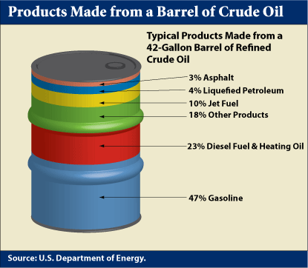
Usage
Crude oil is processed in oil refineries into useful materials. Oil refineries can produce different petroleum products according to the market demand. These materials mostly consist of energy carriers fuel oil and gasoline. These fuels can include diesel fuel, jet fuel, heating oil and heavy fuel oils. Heavy fractions can be used in making roads with asphalt. Refineries also produces chemicals that are used to produce plastics and other materials.
United States is by far the largest user of oil. Consuming around 19,1 million barrels per day it is followed by China 9,4 million barrels. United States consumes more than China, Japan and India combined in 2010. Those three countries are 2nd,3rd and 4th in crude oil consumption respectively. We will give further information about crude oil demand later on.
Creation
Crude oil believed to be formed from compression and heating of ancient organic materials over long periods of time. Oil is formed from planktons and algae that died and their remains settled on ocean floor. Their remains are covered with sediment. Eventually temperature and pressure became so high that remains converted to kerogen and then to natural gas or crude oil. This sediment is known as source rock.
If source rock has openings in it oil can move through it and can go upwards direction. The oil can push their way up if source rock has faults like those caused by earthquakes. If oil finds its way up to the surface it will leak out of the ground. This is how ancient cultures found out oil. And companies use satelite imagery to find out oil leaks around the world to find new crude oil deposits to drill.
We are only concerned with oil that is profitable and this oil needs to be trapped in the ground. This happens only if the sediment of oil reserve is not faulty. And this sediment has to be large as well to create a large enough oil trap. Diagram below shows some types of oil traps under the ground. Pink area is salt, gray is rock layer and blue is oil.
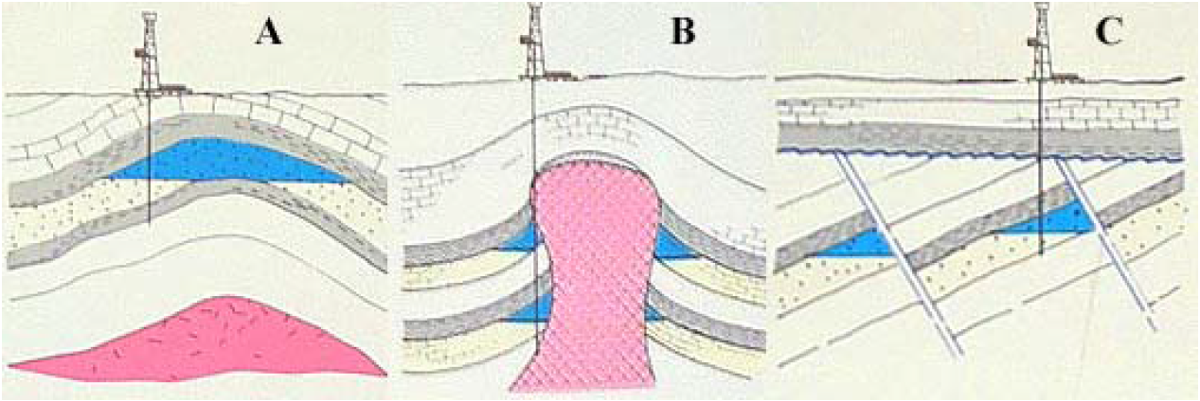
A-Anticlinal trap B-Salt dome trap C-Fault block trap
Exploration
Exploration is one of the most important aspects of oil production. A company must determine locations that have enough resources to make profit.
First we have to look for rock types in a region to see if they are good for oil traps. Geologists can use satellite photographs to make accurate assesment. This will narrow down the sites we will be looking for oil but best way of finding oil is drilling. And drilling is not cheap. Drilling for oil on surface can cost million dollars and drilling off-shore can cost tens of million dollars.
Before drilling for oil companies are using sound waves to determine if theres oil underground. We need big sound waves created by dynamites for sound to go under the rocks and reach oil and bounce back from there. For off-shore oil supplies companies use air guns these machines can create sound equal to several dynamites going off.
After all those assesments and analysis companies will determine if they will reach oil if they drill. They will use their years of experience and make a final decision.
Mineral rights
We now know where to drill but in order to drill and gather oil from there we have to have rights to gather resources from that land. You can own a land but if you dont have the rights to gather resources you can't do any drilling there.
Usally governments will open auction for oil fields and oil companies place their bids to lease the oil field for a duration. Companies will make their bids based on their assesment and analysis of the field and how much profit they can make.
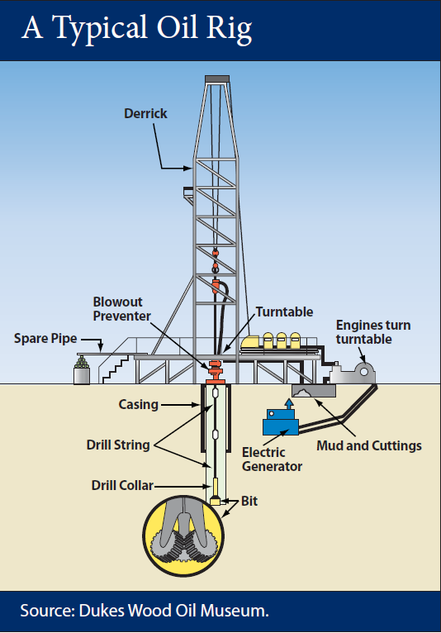
Drilling
Let's say we know a location that has potential to be profitable oil reserve and we have rights to gather oil. Now we have to drill the oil. Drilling is done through oil rigs with 10 inch wide hole into earth. This oil rig will drill through rocks and will reach oil reserve.
Now we reached oil we have to gather it. Even the best production methods produces only one-third of the oil in reserve. To get the remaining oil companies use a technique called “enhanced oil recovery”. With this method remaining oil retrieved by Injecting gases or fluids into reserve making it mobile more likely to flow to wells.

Refiniment
Crude oil after brought into surface from the reserves will go into a refiniment process in refineries. This process consists of 3 main steps: seperation, conversion and purification.
Seperation
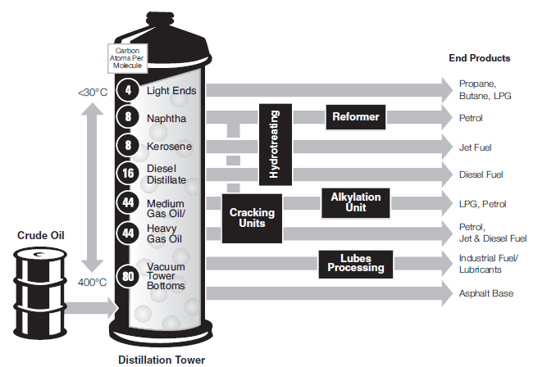
Seperation is the first step in refining crude oil. Seperation is done in distillation towers. Crude oil put into these towers and will get heated up to 400 Celcius. Products in crude oil will vaporize going up the tower. Temperature inside the tower gradually decreases with lowest temperature at the top. This way products that are liquid at certain temperature points cannot go up further and will go through the valves seperating the crude oil. Products we got from valves are not finished products and will be processed later on.
Conversion
Some of the unfinished products we got from seperation not that high valued, like heavy oils. These heavy oils contains long carbon chains that we can break up into more useful materials. These technologies are called Fluidised Catalytic Crackers, Cokers and Hydrocrackers. These systems will convert less useful products into useful expensive ones that we can make more profits.
Purification
Purification process is sulphur removal from the end products. Sulphur removal is done by Hydrotreating. This sulphur can be sold as well increasing profits of refinery.
Historical Oil Prices
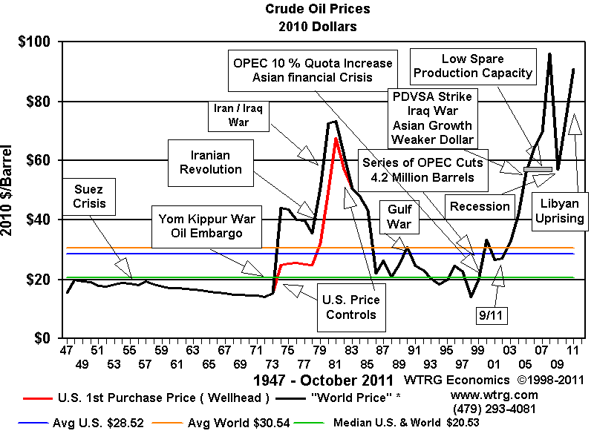
As we can see from the above chart that crude oil prices in history were highly volatile. Crude oil prices effected by events distrupting oil production. Since majority of the oil production is done in middle-east with its chaotic situation after World War 2 price volatility is no suprise. Economic troubles effected crude oil prices as well we can see the recession 2008.

Supply
International Energy Agency reported in 2011 December that global oil supply is projected at around 90.5 million barrels per day in 4th quarter of 2012. OPEC countries supply projected at 30.6 million barrels only while OPEC countries have 80% of current proven oil reserves in the world.
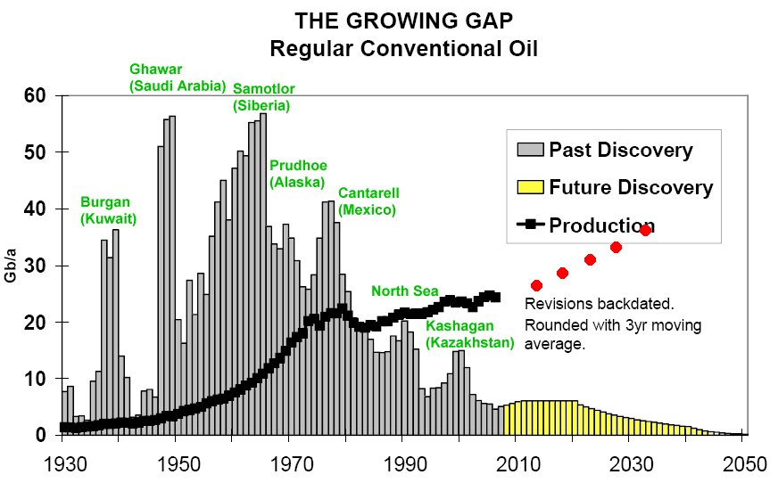
In order to supply more oil first we have to discover oil supplies. This data is from ExxonMobil. Yellow areas are estimates from 2008. Oil explorations in 1965 peaked at 60 billion barrels annually but this number dropped to 15-20 billion barrels annually in 2010 according to a report from Reuters. As we can see from the table oil production is increasing and projected to increase in the future to match market demands. And we can also see that there are not enough explorations to catch with production. This exploration-production gap is increasing each year and we can't find enough oil and we have to replace oil in some way. We will be giving more info about crude oil predictions in forecasts section.
ExxonMobil company spekesman William J.Cummings said “All the easy oil and gas in the world has pretty much been found. Now comes the harder work in finding and producing oil from more challenging environments and work areas.“ in December 2005. Former chairman of Shell Lord Ron Oxburgh said “It is pretty clear that there is not much chance of finding any significant quantity of new cheap oil. Any new or unconventional oil is going to be expensive.” in October 2008.

Oil Reserves
Oil reserves in the world divided into two groups proven and unproven. Proven resources are reserves that have 90% or more chance of production.
Proven Oil Reserves in the World 2012
Country | Reserves  (billion barrels) | Production  (billion barrels) | Life Years
Venezuela | 296.5 | 2.1 | 387
Saudi Arabia | 265.4 | 8.9 | 81
Iran | 175 | 2.7 | 178
Canada | 151.2 | 4.1 | 101
Iraq | 143.1 | 2.4 | 163
United Arab Emirates | 136.7 | 2.4 | 156
Kuwait | 101.5 | 2.3 | 121
Russia | 74.2 | 9.7 | 21
Kazakhstan | 49 | 1.5 | 55
Libya | 47 | 1.7 | 76
Nigeria | 37 | 2.5 | 41
Qatar | 25.41 | 1.1 | 63
China | 20.35 | 4.1 | 14
United States | 19.4 | 5.5 | 10
Angola | 13.5 | 1.9 | 19
Algeria | 13.42 | 1.7 | 22
Brazil | 13.2 | 2.1 | 17
Life year data calculated from reserves/production ratio
Current proven oil reserves in the world is above. This table changes as more resources found. Venzuel became number 1 country in the world in proven oil reserves with recent reserve explorations. We can see from reserves and production numbers that some countries wont be producing oil in near future because they will be running out of reserves like United States, China, Russia. Some countries are under-producting compared to amount reserves. Venezuela, Iran, Iraq, UAE and Kuwait are some of those countries.
Former VP of Saudi Aramco Sadad I. Al-Husseini said “[World] reserves are confused and in fact inflated. Many of the so-called reserves are in fact resources. They're not delineated, they're not accessible, they’re not available for production.” in October 2007.
American diplomats in Riyadh warned in confidential cables written between 2007-2009 that Saudi Arabia's ability to boost oil production much above current levels is questionable and country's overall crude reserves may have been overstated by up to 40 percent. Confidental cables released by Wikileaks and published on The Guardian newspaper in Britain.
These are specilations but some countries inability to increase their production further is concerning over available reserves.
Consumption
BP reported that OECD consumption declined by 1.2%, the fifth decrease in the past six years, reaching the lowest level since 1995. Outside the OECD, consumption grew by 2.8%. Despite strong oil prices, oil consumption growth was below average in producing regions of the Middle East and Africa due to regional unrest. China again recorded the largest increment to global consumption growth 5.5% although the growth rate was below the 10-year average.
Forecasts
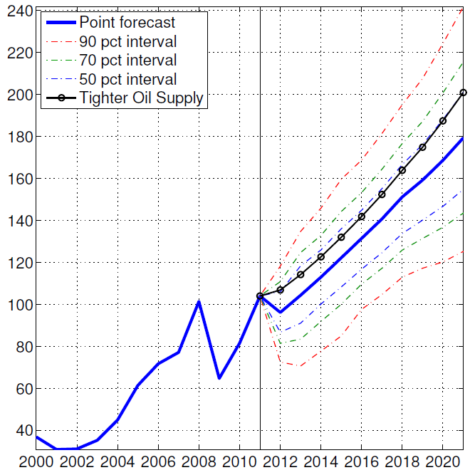
IMF published a report on future of oil prices in May 2012. According to this report their prediction is that world oil production increase will be small. This small increase won't be enough to keep oil prices down. IMF expects oil prices to near doubling permanently over the coming decade. IMF calls this an uncharted territory for the world economy, whşch has never experienced such for more than a few months. IMF also suspect that the assumption that technology is independent of the availability of fossil fuels may be inappropriate, so that a lack of availability of oil may have aspects of a negative technology shock. In that case the macroeconomic effects of binding resource constraints could be much larger, more persistent, and they would extend well beyond the oil sector.IMF Oil Price Forecast with Error Bands ( in real 2011 US dollars)
Peak Oil
Peak oil is the point at which the world's oil supplies go into irreversible decline – is a long-running argument that has not yet had much impact on energy policy. Some gelogists argue that peak oil is either very close or has passed, and the world will never again be able to produce the 83m barrels per day that flowed in 2008. They are exasperated by what they see as the complacency of policy makers and analysts, particularly the International Energy Agency, which predicted that oil production could reach 103 million barrels per day by 2030.(Financial Times Lexicon)
The aggregate production rate from an oil field over time usally grows until the rate peaks and then declines until field is deplated. This is called peak oil for the certain oil field.
Status Of Nigerian Oil Fields
Nigeria's hydrocarbon resources are the mainstay of the country's economy, but development of the oil and natural gas sectors is often constrained by instability in the Niger Delta.
Nigeria is the largest oil producer in Africa and has been a member of the Organization of Petroleum Exporting Countries (OPEC) since 1971. In 2011, Nigeria produced about 2.53 million barrels per day (bbl/d) of total liquids, well below its oil production capacity of over 3 million bbl/d, due to production disruptions that have compromised portions of the country's oil for years. The Nigerian economy is heavily dependent on the oil sector, which accounts for over 95 percent of export earnings and about 40 percent of government revenues, according to the International Monetary Fund (IMF).
The oil industry is primarily located in the Niger Delta where it has been a source of conflict. Local groups seeking a share of the oil wealth often attack the oil infrastructure and staff, forcing companies to declare force majeure on oil shipments. At the same time, oil theft, commonly referred to as "bunkering," leads to pipeline damage that is often severe, causing loss of production, pollution, and forcing companies to shut-in production. Protest from local groups over environmental damages from oil spills and flaring undermined relations between local communities and international oil companies (IOCs). The industry has been blamed for pollution that has damaged air, soil, and water, leading to losses in arable land and decreasing fish stocks.
In addition to oil, Nigeria holds the largest natural gas reserves in Africa, but has limited infrastructure in place to develop the sector. Natural gas that is associated with oil production is mostly flared, but the development of regional pipelines, the expansion of liquefied natural gas (LNG) infrastructure, and policies to ban gas flaring are expected to accelerate growth in the sector, both for export and domestic use in electricity generation. Uncertainties in Nigeria's investment policies and regulatory framework have caused a slowdown in oil and gas exploration activity, and delays in project development, including LNG projects. However, the long-awaited and delayed Petroleum Industry Bill (PIB) could potentially iron out investment uncertainties and set a regulatory framework for the country's oil and gas industry.
Approximate Oil Reserves in Nigeria
According to Oil and Gas Journal (OGJ), Nigeria has an estimated 37.2 billion barrels of proven oil reserves as of the end of 2011. The majority of reserves are found along the country's Niger River Delta and offshore in the Bight of Benin, the Gulf of Guinea, and the Bight of Bonny. Current exploration activities are mostly focused in the deep and ultra-deep offshore with some activities in the Chad basin, located in the northeast of the country. The government hopes to increase proven oil reserves to 40 billion barrels in the next few years; however, exploration activity levels are at their lowest in a decade and only three exploratory wells were drilled in 2011, compared to over 20 in 2005. Rising security problems related to oil theft, pipeline sabotage, and piracy in the Gulf of Guinea, coupled with investment uncertainties surrounding the long-delayed PIB, have curtailed oil exploration projects and impeded the country from reaching its ongoing target to increase production to 4 million bbl/d. Instead, crude oil production averaged 2.13 million bbl/d in 2011, roughly the same as it was a decade ago, and total liquids production averaged 2.53 million that same year, which is still below the peak production of 2.63 million bbl/d reached in 2005.
Production of Crude oil by Nigeria
In 2011, crude oil production averaged close to 2.13 million barrels per day (bbl/d) , up from 2.05 million bbl/d in the previous year. EIA's recent estimates show that crude output rose slightly again in 2012 and averaged almost 2.15 million bbl/d for the first half of this year. The recent increase in production is due to the expansion of existing fields and new production from deepwater fields. The latest major deepwater field to come onstream was Total's Usan field, which began producing over 100,000 bbl/d in July 2012 and is expected to reach180,000 bbl/d by the end of this year.
Oil production in Nigeria reached its peak of 2.63 million bbl/d in 2005, but began to decline significantly as violence from militant groups surged, forcing many companies to withdraw staff and shut in production. The lack of transparency of oil revenues, tensions over revenue distribution, and environmental damages from oil spills, coupled with local ethnic and religious tensions, have created a fragile situation in the oil-rich Niger Delta basin. As a result, crude oil production plummeted by more than 25 percent by 2009, four years after reaching its peak.
Towards the end of 2009, an amnesty was declared and the militants came to an agreement with the government whereby they handed over weapons in exchange for cash payments and training opportunities. The rise in oil production after 2009 was partially due to the reduction in attacks on oil facilities following the implementation of the amnesty program, which allowed companies to repair some damaged infrastructure and bring some supplies back online. Another major factor that contributed to the upward trend in output was the continued increase in new deepwater offshore production. The government began taking measures to attract investment in deepwater acreage in the 1990s in order to boost production capacity and diversify the country's oil fields, as security issues in the Niger Delta escalated. In order to incentivize investments in deepwater areas, which involve higher capital and operating costs, the government offered production-sharing contracts (PSC) in which IOCs received a greater share of revenue as the depth increased.
Although terms within the PSCs have been revised over time to provide the government with larger shares in revenue, the policy did facilitate greater investment and production in deepwater fields. The first deepwater field began production in 2003, and since then output from deepwater fields has added over 800,000 bbl/d to the country's production capacity. As an OPEC member, Nigeria has agreed to a crude oil production quota of 1.704 million bbl/d. However, the country still plans on bringing online several projects in the next few years. Planned upstream developments, particularly deepwater projects, should increase Nigerian oil production in the medium term, but the timing of these startups will depend heavily on the passing of the PIB and the fiscal/regulatory terms it requires of the oil industry. Many of the planned projects described below have already been delayed.
Recent developments
The government has been planning to transform NNPC into a more profit-driven company that can seek out private financing. While these discussions have been underway for many years, a Petroleum Industry Bill (PIB) is currently being debated by the National Assembly to reform the entire hydrocarbon sector. Parts of the bill have recently been approved as standalone laws, while the different agencies and roles of the new national oil company and the NNPC have yet to be fully defined. Differing versions of the PIB are currently under debate, especially around more contentious points such as the renegotiation of contracts with international oil companies, the changes in tax and royalty structures, and clauses to ensure that companies use or lose their assets. The ongoing debate has delayed investments in both the oil and natural gas sectors.
As part of the energy sector reform, in April 2010, then acting president (now president) Goodluck Jonathan signed the Nigerian Content Development Bill (NCD) into law. The bill aims to increase the role of Nigerian companies in all aspects of the oil and gas industry. The new law requires that Nigerian companies obtain contracts and win bids so long as the local company is capable, the Nigerian content is higher, and the bid is not more than 10 percent higher than the competing bid. According to the African Oil and Gas Monitor (Afroil), the NCD applies to all contracts worth over US$1 million and also applies to insurance, banking, and other sectors tied into the oil industry.
The distribution of oil revenue has been a very contentious issue in the country, since all revenue, including production proceeds, corporate tax, customs duties, and value-added tax, goes directly to the federal government account. The lack of transparency and mismanagement of oil revenue has sparked mistrust among the federal government, states, and local councils. The 1999 constitution carved out a revenue-sharing arrangement in which 13 percent of oil revenue from onshore production goes directly to the nine oilproducing states in the Niger Delta, with the remaining revenue allocated to the federal government (47.2 percent), states (31.1 percent), local councils (15.2 percent), and National Priorities Services Fund (6.5 percent). Disagreement over the current revenue-sharing arrangement is one of the main issues driving the political tension, theft, and sabotage in the Niger Delta, and groups have demanded to extend their revenue-share to offshore production and increase their onshore revenue-share to 50 percent. However, the effect that the PIB will have on the current revenue-sharing arrangement is unclear.
International oil companies In Nigeria
Foreign companies operating in joint ventures (JVs) or production sharing contracts (PSCs) with the NNPC include ExxonMobil, Chevron, Total, Eni, Addax Petroleum (recently acquired by Sinopec of China), ConocoPhillips, Petrobras, StatoilHydro, and others.
Shell has been working in Nigeria since 1936, and currently operates the largest nameplate crude oil production capacity, estimated to be between 1.2-1.3 million bbl/d. However, the company has been hardest hit by the instability as much of its production is in shallow water and onshore the Niger Delta. Much of Shell's crude oil production capacity is shut-in, some since as far back as early 2006. According to Shell, the total oil produced from Shellrun operations averaged 974,000 bbl/d in 2011.
Shell operates in Nigeria through the Shell Petroleum Development Company of Nigeria Limited (SPDC) and the Shell Nigeria Exploration and Production Company Limited (SNEPCo). SPDC is the largest oil and gas company in Nigeria and is a joint venture between NNPC (55%), Shell (30%), Elf Petroleum Nigeria Limited — a subsidiary of Total — (10%), and Agip (5%). SPDC's operations include a network of pipelines, nine gas plants, and two export terminals. Shell owns 100 percent of SNEPCo, which was formed in 1993 to develop Nigeria's deepwater oil and gas resources offshore. Under a PSC with NNPC, it operates the Bonga deepwater oil and gas project and is a venture partner in theErha deepwater oil and gas project with ExxonMobil.
ExxonMobil, the second largest IOC, operates fields producing approximately 800,000 bbl/d (700,000 bbl/d of crude) in partnership with NNPC. Chevron is the third largest oil producer in Nigeria and produced an average of 516,000 bbl/d of crude oil in 2011. The company operates under its subsidiary, Chevron Nigeria Limited, and holds 40 percent interest in 13 concessions under a joint venture arrangement with NNPC. Most of its oil projects are in shallow water and onshore in the Niger Delta. Chevron also has interests in deepwater projects, particularly its largest deepwater discovery Agbami.
Total and Eni are the fourth and fifth largest oil producers in the country, producing 179,000 bbl/d and 96,000 bb/d in 2011, respectively. Total operates several offshore projects and one onshore. Total is the operator of the Usan deepwater field that came online in July 2012. Total's smaller share of production has been unaffected in recent years whereas Eni/Agip has had some incidents, specifically at the Brass River terminal that have shut-in varying volumes of production since December of 2006.
Why should we choose Nigeria for our investment?
A lot has made our mind to choose Nigeria for investments, particularly in the oil sector of the country, which can be explain in the next section:
Nigerian government accepts the private sector as the engine of growth and creator of wealth, therefore its responsibility is to provide enabling environment for the investors to operate conductively.
What are the incentives for investing in Nigeria?
The factors that will encourage investors to have interest in investing in Nigerian oil may largely depend on the purpose of the investment available in the country, which is obviously stated below:
Being the best oil production country in African Continent and one of the world’s best oil production countries, ranked between 11th-14th (2011-2012, world position), investment opportunities greatly expected.
- ACCESS TO LAND
- Any Company incorporated in Nigeria is allowed to have access to land rights for the purpose of its activity in any state in the country. it is, however, a requirement that industrial companies comply with regulations on use of land for industrial purposes and with environmental regulations.
- Nigerian National Petroleum Corporation (NNPC):
Is a public organization that would, on behalf of government adequately manage all government interests in the Nigerian Oil Industry. Therefore, both foreign and domestic investors were being encouraged through improved fiscal incentives in the oil and gas industry. The organization has two major areas named as (Upstream and Downstream) with required investment opportunities for both foreigners and domestic investors
In the upstream and downstream sectors, the following are some of the areas where there are pressing needs for investors;

Upstream Activities:
- Petroleum Exploration and Exploitation.
- Construction and installation.
- Maintenance.
- Pipelines.
- Transportation support services.
- Manufacturing of consumable materials in exploration such as explosives, detonators, steel casting, magnetic tapes, etc.
Downstream Activities:
- Domestic production and marketing of liquefied petroleum gas (LPG).
- Manufacturing of LPG cylinders, distribution and development of simple, flexible and much less expensive gas burner to encourage the use of gas instead of wood and other fuels.
- Establishment of processing plants and industries for the production of refined mineral oil petroleum jelly grease.
- Establishment of chemical industries such as distillation units for the production of naphtha and other special boiling point solvents used in other food processing industries.
- Establishment of small scale industries to produce chemicals and solvents from natural gas, for example chlorinate methane, formaldehyde, acetylene, etc.
What are risks of investing in Nigeria?
Where there are benefits risk may probably arise knowingly or unknowingly.Therefore, it is good to notice the following expected/ possible risks that an investor may encounter in one way or others:
- Oil exploitation and conflict in the Niger Delta region of Nigeria: This is the region where oil production is taking place located in south-south part of the country and some part of south west and south east of Nigeria. In this area a lot of community group work against both government and investors as stated below;
- Terrorism threat: There is a terrorist group called MEND meaning “Movement for the Emancipation of Niger Delta” is a militant group seeking to assume control of Nigeria’s energy resources in the Niger Delta where they involved in protesting government by all means with aim of seizing power.
- Kidnap: There is also kidnapping threat in some part of Nigeria particularly in the Niger Delta region mainly for financial or political gain and can be motivated by criminality or terrorism, as shown in the picture below;

Militant Emancipation Group in Niger Delta Region of Nigeria
- Scams; The scams come in many forms, and can pose great financial loss to victims. Therefore, know where and who you are sending money to. And look for authorized dealer in exchange and conversion of funds.
- Infrastructure ; some factors associated with unavailability of societal amenities may cause risk in the process of investment like electric power supply, road congestion as result of bad or substandard roads and others.
- Weather; Nigeria experiences heavy rainfall during the wet season (June-October) and flash flooding can occur, water borne disease may poses risk during rainy season.
What are regulations over oil production?
Petroleum operations and activities are regulated primarily by federal government agencies, although some state governments and local governments also have regulations and bye-laws that may affect activities in oil and gas industry.
For successful investment in Nigeria both foreign and domestic, one has to follow the following guidelines in order to achieve the goal of investing Nigeria particularly in the oil sector;
- Government License: Any investor or Private person most register with government, because, it is stated that every property and mineral resources are in control of the federation and shall be managed by the federal government directly or indirectly under some agencies like NNPC and can assisted by other organizational bodies authorized by government like NIPC, IOCs, etc. for example the petroleum act provide three types of licenses for upstream operations: Oil Exploration License (OEL), Oil Prospecting License (OPL) and Oil Mining Lease (OML).
- Petroleum Profits Tax: Nigerian law by virtue of the Petroleum Profits Tax Act requires all companies engaged in the extraction and transportation of petroleum to pay tax. The taxable income of a petroleum company comprises proceeds from the sale of oil and related substances used by the company in its own refineries plus any other income of the company incidental to and arising from its petroleum operations.
- There is also a general requirement for both International Oil Companies (IOCs) and the oil service companies to train Nigerians to fill specified positions in their companies.
- IOCs and oil service companies are allowed, subject to obtaining the necessary expatriate quota, to employ expatriates to fill key positions in their organizations. They are however required to train Nigerians over a period of time to take over from the expatriates.
- Nigerian Investment Promotion Council (NIPC): Act also states that no person who owns, whether wholly or in part, the capital of any enterprise shall be compelled by law to surrender his interest in the capital to any other person.
- The NIPC Act further provides that where there is a dispute between an investor and the government, the dispute can be resolved by any means agreed upon the parties or in accordance with the rules of the International Centre for Settlement of Investment Disputes (ICSID).

What are costs of investing in Nigerian oil fields?
Regardless of the underlying reasons for changes in oil prices, the cost of investment in any field can only be determine fundamentally in respect of understanding the company and sectors in which you invest, therefore make sure you do research or consult an investment professional prior to committing your money, so that you will have outlined information when predicting price changes to help ensure a profitable investment. Because;
- The oil market provides a diverse array of options for the potential investor. From indirect exposure via an energy-related stock to more direct investment in a commodity-linked ETF (Exchange Trade Fund), it trades like a stock, have no net asset value to be calculated every day.
- But the government has unified the price of its products with differentials in transportation costs due to distance variation.
Conclusion
In conclusion we see that crude oil production is expected to rise with new technologies and more wells being added. But rising production won't be enough for oil prices to stay down. That's because oil reserve explorations are diminishing and world is already consuming well above the crude oil we are finding each year. We saw that this gap is pretty concerning. And it is expected that on some parts of the world oil production will diminish because of peak oil. Nigerian oil reserves needs to be asssesed in terms of their capabilities. A declining oil well will be giving us worse returns over the years.
Also Nigeria is distant to europe and america this rules out to posibility of pipelines. Shipping the crude oil with tankers directly from country might be worse than processing inside the country and selling it is products seperatly. Nigerian oil fields are under terrorist threats. Cooperating with those terrorists seems vital since country is incapable of securing it is oil wells.

